
BAR CODE MEDICATION ADMINISTRATION (BCMA)
PHARMACY CHUI USER MANUAL
Version 3.0
February 2004
(Revised March 2008)

Department of Veterans Affairs
VistA Health Systems Design & Development

Revision History

Each time this manual is updated, the Title Page lists the new revised date and this page describes the changes. If the Revised Pages column lists “All,” replace the existing manual with the reissued manual. If the Revised Pages column lists individual entries (e.g., 25, 32), either update the existing manual with the Change Pages Document or print the entire new manual.

Date | Revised Pages | Patch Number | Description
03/2008 | iii-iv  5, 31-32,  34 a-b, 41 | PSB*3*2 | Section 3.1 – Exhibit 1 screen updated (p. 5).  Section 3.10 - References to Zebra printers restored (p. 31); sample barcode screens deleted (p. 32).  Section 3.12 added, references to “Dosage” changed to “Dose” and space between colon and dose measurement deleted (pp. 34 a-b).  (E. Williamson, PM; G. O’Connor, S.B. Scudder, Tech Writer)
08/2006 | iv,  31- 32 | PSB*3*2 | Note: The functionality listed below will be activated with the release of PSB*3*2.  – Updated Table of Exhibits to include Exhibits 22a and 22b. (p. iv)  – Updated Section 3.10, Label Print. Removed specific references to the Zebra printer to accommodate new feature to support multiple bar code printers, and updated instructions for creating a bar code label. Included new sample bar code label samples for Unit Dose and Ward Stock labels. (p. 31-32)  (R. Singer, PM; M. Newman, Tech Writer)
07/2004 | 19, 20 | PSB*3*5 | – Updated the second paragraph to include the “Allergies” information.  (p. 19)  – Updated the “Exhibit 12: Medication Administration History Report by Patient” to show the removal of the Reactions header and the inclusion of the ADRs header and the Allergies header. (p. 20)
02/2004 |  |  | Original Released BCMA V. 3.0 Pharmacy CHUI User Manual.

TABLE OF CONTENTS

1 INTRODUCTION 1
1.1 What is BCMA? 1
1.2 Features of BCMA 1
2 About This Manual 3
2.1 Special Notations—Documentation Conventions 3
2.2 Package Conventions 3
2.3 Intranet Documentation 3
2.4 On-line Help 3
3 BCMA Menu—Pharmacy Option 5
3.1 Using the Medication Administration Menu Pharmacy Option 5
3.2 Using ScreenMan Format to Request a Report 6
3.3 Medication Administration Log Report 8
3.4 Missed Medications Report 11
3.5 Due List Report 15
3.6 Medication Administration History (MAH) Report 19
3.7 Missing Dose Request 21
3.8 Missing Dose Followup 25
3.9 Missing Dose Report 28
3.10 Label Print 31
3.11 Drug File Inquiry 33
3.12 Barcode Label Print 34a
glossary 35
INDEX 41

TABLE OF EXHIBITS

Exhibit 1: BCMA Pharmacy Option Menu Screen 5
Exhibit 2: Report Request Using ScreenMan Format Screen 6
Exhibit 3: Medication Administration Log Report Screen 8
Exhibit 4: Medication Administration Log Report by Patient 9
Exhibit 5: Medication Administration Log Report by Ward 10
Exhibit 6: Missed Medications Report Screen 12
Exhibit 7: Missed Medications Report By Patient 13
Exhibit 8: Missed Medications Report By Ward 14
Exhibit 9: Due List Report Request Screen 15
Exhibit 10: Due List Report by Patient 17
Exhibit 11: Due List Report by Ward 18
Exhibit 12: Medication Administration History Report by Patient 20
Exhibit 13: Missing Dose Request Screen 21
Exhibit 14: Missing Dose Request Confirmation Screen 23
Exhibit 15: Missing Dose E-mail Notification 24
Exhibit 16: Missing Dose Followup Request Screen 25
Exhibit 17: Missing Dose Request Pharmacy Follow-up Information Screen 26
Exhibit 18: Pharmacy Reasons Needed Selection Table 27
Exhibit 19: Missing Dose Report Request Screen 28
Exhibit 20: Missing Dose Report 30
Exhibit 21: Bar Code Label Screen 31
Exhibit 23: Drug File Inquiry Screen 1 33
Exhibit 24: Drug File Inquiry Screen 2 34
Exhibit 25: Bar Code Label Print Screen 34a
Exhibit 26a: Sample Unit Dose Bar Code Label 34b
Exhibit 26b: Sample Ward Stock Bar Code Label 34b

INTRODUCTION

What is BCMA?
The Bar Code Medication Administration (BCMA) V. 3.0 software includes routines and files, Phase Release changes for BCMA V. 2.0, maintenance fixes, and enhancements. The enhancements are a direct result of feedback from the BCMA Workgroup and our many end users.

BCMA software is designed to improve the accuracy of the medication administration process. By automating this process, Department of Veterans Affairs Medical Centers (VAMCS) can expect enhanced patient safety and patient care.

As each patient wristband and medication is scanned with a bar code scanner, BCMA validates that the medication is ordered, timely, and in the correct dosage — as well as electronically updates the patient’s Medication Administration History (MAH) Report.

The electronic information provided by BCMA V. 3.0 improves the clinician’s ability to administer medications safely and effectively to patients on wards during their medication passes. It also helps to improve the daily communication that occurs between Nursing and Pharmacy staffs.

Features of BCMA
BCMA V. 3.0 provides the following features:

- Increases medication administration accuracy.
- Improves the efficiency of the medication administration process by capturing drug accountability data.
- Records Unit Dose, IV Push (IVP), IV Piggyback (IVPB), and large-volume IVs administered to patients.
- Provides the CPRS Med Order Button, a “link” to the Computerized Patient Record System (CPRS) for electronically ordering, documenting, reviewing, and signing verbal- and phone-type STAT and NOW (One-Time) orders for Unit Dose and IV medications already administered to patients.
- Increases the information available to nursing staff at the patient point of care.
- Reduces wasted medications.
- Improves communication between Nursing and Pharmacy staffs.
- Provides a real-time Virtual Due List (VDL) of orders for medication administration.
- Records missing doses and sends the requests electronically to the Pharmacy.
- Provides a point-of-care data entry/retrieval system.
- Provides full compatibility with the existing VistA system.
- Identifies Pro Re Nata (PRN) entries that require Effectiveness comments.
- Replaces the manual Medication Administration Record (MAR) with a Medication Administration History (MAH) to provide an automatic record of a patient’s medication administration information.
- Provides a list of variances that identify Early or Late medication administrations and late PRN Effectiveness entries.
- Provides the ability to document the patient’s pain score in BCMA and store it in the Vitals package.

About This Manual
This manual contains a description of the Character-based User Interface (CHUI) BCMA options for the Pharmacy user. It is organized around the Medication Administration Menu Pharmacy Options. It explains how to access and use each option, and provides sample screen captures and reports. An Index and a Glossary are available at the back of this manual.

Special Notations—Documentation Conventions
Responses in boldface type indicate what you should type at your computer screen. Example: At the “Patient/Ward:” prompt, type P for Patient or W for Ward.

Text centered between arrows represents a keyboard key that needs to be pressed for the system to capture a user response or move the cursor to another prompt. <Enter> indicates that the Enter key (or Return key on some keyboards) must be pressed. <Tab> indicates that the Tab key must be pressed. Example: Press <Tab> to move the cursor to the next prompt. Enter Y for Yes or N for No, and then press <Enter>.

- Indicates especially important or helpful information.

Package Conventions
Up-arrow (caret or a circumflex)
In CHUI BCMA, you can move back to a previous screen by entering a ^ and then pressing <Enter>. Repeat this process until you locate the desired screen.

Intranet Documentation
You can locate this and other BCMA-related documentation on the Intranet, from the VistA Documentation Library (VDL), at the following address. It provides background, technical information, and important user documentation.

http://www.va.gov/vdl

 Remember to bookmark this site for future reference.

On-line Help
?, ??, ???
On-line help is available by entering one, two, or three question marks at a prompt. One question mark elicits a brief statement of what information is appropriate for the prompt; two question marks elicits more help, plus the hidden actions shown above; and three question marks will provide more detailed help, including a list of possible answers, if appropriate.

BCMA Menu—Pharmacy Option

Using the Medication Administration Menu Pharmacy Option
The BCMA Pharmacy Option Menu, as illustrated in Exhibit 1, lets Pharmacy personnel access information that has been entered via the BCMA Graphical User Interface (GUI) VDL. Because BCMA operates in real time, scanned information is available as soon as the scan is successfully completed. You can access the Pharmacy Option Menu from any VistA-enabled terminal within the VAMC.

 Several of these options are available under both the Nursing and the Pharmacy menu options. The options that are unique to Pharmacy include Missing Dose Followup, Missing Dose Report, Label Print, and Barcode Label Print.

Exhibit 1: BCMA Pharmacy Option Menu Screen
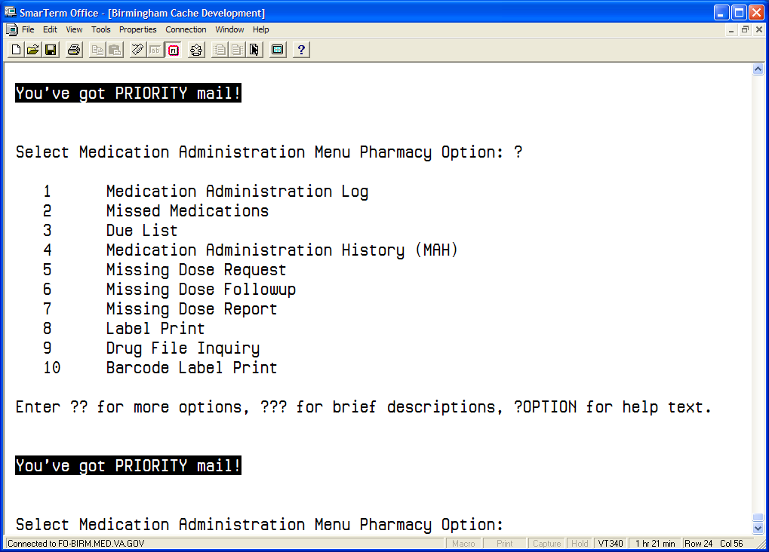

To select a Pharmacy option:
- At the “Select Medication Administration Menu Pharmacy Option:” prompt, enter the number of the desired option.
- Press <Enter> to display the Sort Screen for the option chosen.

Using ScreenMan Format to Request a Report
Many of the Pharmacy options use a common screen to define selection criteria for reports, as illustrated in Exhibit 2, Report Request Using ScreenMan Format Screen. Other options use specific screens. This section explains the screen prompts for all reports using the Report Information Sort Screen and gives instructions for entering information. Following this section are sample reports that you can run from each of the Medication Administration Menu Pharmacy options.

Exhibit 2: Report Request Using ScreenMan Format Screen
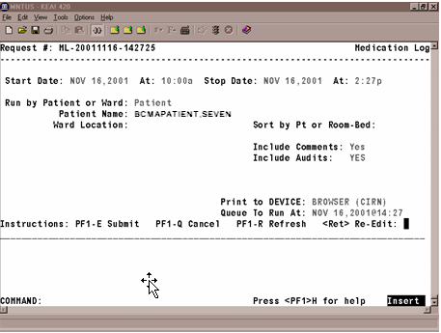

Many of the reports can be sorted and printed in the following ways:
- By patient. The information will display chronologically.
- By ward. The system can sort the information by patient or room/bed, and display it chronologically within each patient.

To request a report using ScreenMan:
- At the “Start Date:” prompt, type the start date of the report, and then press <Enter>.
Note: The cursor moves to the next prompt each time that you press <Enter>.

- To display a list or a standard date and time format, enter a ? in any date or time prompt, and then press <Enter>.

- At the first “At:” prompt, type the start time of the report (in HHMM format), and then press <Enter>.
- At the “Stop Date:” prompt, type the stop date, and then press <Enter>.
- At the second “At:” prompt, type the stop time (in HHMM format), and then press <Enter>.
- At the “Run by Patient or Ward:” prompt, type P for Patient or W for Ward, and then press <Enter>.
- If you are sorting the report by ward, at the “Ward Location:” prompt, type the ward designation, and then press <Enter>. At the “Sort by Pt or Room-Bed:” prompt, type P for Patient or R for Room, and then press <Enter>.
- If you are sorting the report by patient, at the “Patient Name:” prompt, type the patient’s name or Social Security Number (SSN), and then press <Enter>.

 To display a list or a standard format, enter a ? at any “Patient Name:” prompt, and then press <Enter>.

- At the “Include Comments:” prompt, enter Y for Yes or N for No, and then press <Enter>.

 If a “Yes/No” prompt is blank, press <Enter> to respond No.

- At the “Include Audits:” prompt, enter Y for Yes or N for No, and then press <Enter>.
- At the “Print to Device:” prompt, type a valid printer, and then press <Enter>.
- At the “Queue to Run At:” prompt, press <Enter> to accept the date displayed, or enter a date and time, and then press <Enter>. The report will print at the time and date entered.
- At the “<RET> Re-Edit:” prompt, press PF1 (or Num Lock), followed by E, to submit this report for printing. (Other available actions at this prompt are PF1-Q to Quit or PF1-R to refresh the screen.)

The screen clears and the following message displays:

Submitting Your Report Request to Taskman…Submitted!
Your Task Number Is: XXXX

- Depending on how your division is configured, either the PF1 key or Num Lock will be active. For consistency, this manual refers to the PF1 convention, but users are advised that PF1 is the same as Num Lock, if that is the active function at your VAMC.

Medication Administration Log Report
The Medication Administration Log [PSBO ML] option lets Pharmacy personnel print the Medication Administration Log Report, which displays detailed administration information for a specified date/time range. The report can be sorted and printed by patient or by ward, as illustrated in Exhibit 3. When printed by ward, you may sort the view by patient or room/bed. With this sort, the drug administration information will be printed chronologically within each patient.

The Medication Administration Log Report prints in a 132-column output. Exhibit 4, Medication Administration Log Report by Patient, and Exhibit 5, Medication Administration Log Report by Ward, show examples of both Medication Administration Log Reports.

- Throughout this manual, the reports shown are provided for illustrative purposes only. Actual reports may be longer.

To print a Medication Administration Log Report:
1. At the “Select Medication Administration Menu Pharmacy Option:” prompt, type 1, and then press <Enter> to access the Medication Administration Log [PSBO ML] option.
2. See Section 3.2, “Using ScreenMan Format to Request a Report,” for instructions about requesting a Medication Administration Log Report.

Exhibit 3: Medication Administration Log Report Screen
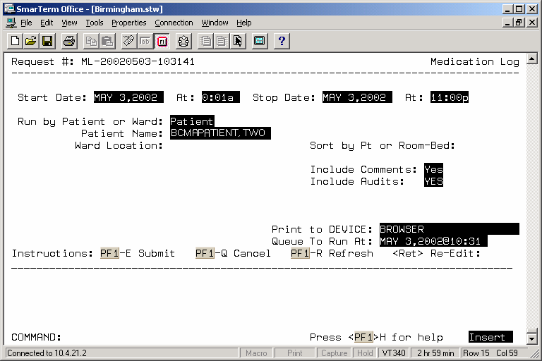

Exhibit 4: Medication Administration Log Report by Patient
Continuing/PRN/Stat/One Time Medication/Treatment Record (Detailed Log) (VAF 10-2970 B, C, D)
Run Date: NOV 16, 2001@14:35
Log Type: INDIVIDUAL PATIENT Page: 1

Patient: BCMAPATIENT,SEVEN SSN: 000-00-1001 DOB: JAN 1,1949 (52)
Sex: MALE Ht/Wt: 182cm/83kg Ward: BCMA Rm 401-4
Dx: COPD Last Mvmt: NOV 27,2000@11:33:30 Type: ADMISSION

Reactions: STRAWBERRIES
===================================================================================================================
Activity Date Orderable Item Action Action
Start Date> [Dose/Sched/Route/Inj Site] By Date/Time Drug/Additive/Solution U/Ord U/Gvn Unit
Stop Date<
-------------------------------------------------------------------------------------------------------------------
11/16/01 13:44 BENZTROPINE [3MG Q6H PO] DD 11/16/01 11:00
Given
11/14/01 12:42> BENZTROPINE 1MG TAB 3.00 3.00 TAB
Comments: 11/16/01 13:44 DD Actually given at 11am computer down during med pass
11/16/01 13:45 DD computer down during 11am med pass
2/22/02 24:00<
Audits: 11/16/01 13:45 DD Field: ACTION DATE/TIME 'NOV 16, 2001@13:44:58' deleted.
11/16/01 13:45 DD Field: ACTION DATE/TIME Set to 'NOV 16, 2001@11:00'.
-------------------------------------------------------------------------------------------------------------------
11/16/01 12:25 PROCHLORPERAZINE [10MG Q6H PRN
IM Inj Site: Right Arm] DD 11/16/01 12:25
Given
11/16/01 12:19> PROCHLORPERAZINE 5MG/ML INJ
2ML 1.00 1.00 10MG
PRN Reason: VOMITING
PRN Effectiveness: Patient's N/V relieved by 10mg of compazine
Entered By: DENVER,DONNA Date/Time: NOV 16, 2001@13:22:55 Minutes: 57
Comments: <No Comments>
2/24/02 24:00<
Audits: 11/16/01 13:22 DD Field: PRN EFFECTIVENESS Set to 'Patient's N/V relieved by 10mg
of compazine'.
-------------------------------------------------------------------------------------------------------------------
11/16/01 12:46 WARFARIN [2MG MO-WE-FR@1300 PO] DD 11/16/01 12:46
Given
11/14/01 12:49> WARFARIN 2MG TABS 1.00 1.00 TAB
Comments: 11/16/01 13:43 DD SELECTED IN ERROR
2/22/02 24:00<
Audits: 11/16/01 13:43 DD Field: ACTION STATUS 'Given' deleted.
11/16/01 13:43 DD Field: ACTION STATUS Set to 'Given'.
------------------------------------------------------------------------------------------------------------------------------------
11/16/01 12:46 AMOXICILLIN [250MG Q8H PO] DD 11/16/01 12:46
Given
11/14/01 12:44> AMOXICILLIN 250MG CAP 1.00 1.00 CAP,ORAL
Comments: <No Comments>
11/28/01 24:00<
Audits: <No Audits>

1/16/01 13:20 MEPERIDINE [50MG ON CALL IM Inj
Site: Right Arm] DD 11/16/01 13:20
Given
11/16/01 12:22> MEPERIDINE 50MG SYRINGE 1.00 1.00 50MG
Comments: 11/16/01 13:20 DD Surgery called for pre op to be administered
2/24/02 24:00<
Audits: <No Audits>
--------------------------------------------------------------------------------------------------------------------
====================================================================================================================
BCMAPATIENT,SEVEN 000-00-1001 Ward: BCMA Room-Bed: 401-4

Exhibit 5: Medication Administration Log Report by Ward
BCMAPATIENT,SEVEN (000001001)
Ward: BCMA Rm-Bed: 401-4

11/16/01 12:25 PROCHLORPERAZINE [10MG Q6H PRN
IM Inj Site: Right Arm] DD 11/16/01 12:25
Given
11/16/01 12:19> PROCHLORPERAZINE 5MG/ML INJ
2ML 1.00 1.00 10MG
PRN Reason: VOMITING
PRN Effectiveness: Patient's N/V relieved by 10mg of compazine
Entered By: DENVER,DONNA Date/Time: NOV 16, 2001@13:22:55 Minutes: 57
2/24/02 24:00<
------------------------------------------------------------------------------------------------------------------------------------
11/16/01 12:46 WARFARIN [2MG MO-WE-FR@1300 PO] DD 11/16/01 12:46
Given
11/14/01 12:49> WARFARIN 2MG TABS 1.00 1.00 TAB
2/22/02 24:00<
------------------------------------------------------------------------------------------------------------------------------------
11/16/01 12:46 AMOXICILLIN [250MG Q8H PO] DD 11/16/01 12:46
Given
11/14/01 12:44> AMOXICILLIN 250MG CAP 1.00 1.00 CAP,ORAL
11/28/01 24:00<
------------------------------------------------------------------------------------------------------------------------------------
11/16/01 13:20 MEPERIDINE [50MG ON CALL IM Inj
Site: Right Arm] DD 11/16/01 13:20
Given
11/16/01 12:22> MEPERIDINE 50MG SYRINGE 1.00 1.00 50MG
2/24/02 24:00<

BCMAPATIENT,ONE (000009678)
Ward: BCMA Rm-Bed: 422-2

<<<< NO MEDICATIONS FOUND FOR THIS TIME FRAME >>>>

BCMAPATIENT,FOUR (000001002)
Ward: BCMA Rm-Bed: 404-1

<<<< NO MEDICATIONS FOUND FOR THIS TIME FRAME >>>>

BCMAPATIENT,FIVE (000001084)
Ward: BCMA Rm-Bed: 420-2

<<<< NO MEDICATIONS FOUND FOR THIS TIME FRAME >>>>

BCMAPATIENT,EIGHT (000001055)
Ward: BCMA Rm-Bed: 420-4

<<<< NO MEDICATIONS FOUND FOR THIS TIME FRAME >>>>

BCMAPATIENT,NINE (000001013)
Ward: BCMA Rm-Bed: 421-1

<<<< NO MEDICATIONS FOUND FOR THIS TIME FRAME >>>>

Missed Medications Report
The Missed Medication [PSBO MM] option lets Pharmacy personnel print the Missed Medications Report, which includes Continuous and One-Time Unit Dose and IV Piggyback medications that were not administered to a patient during a medication pass. This report also includes patient demographics data, adverse drug reaction (ADR) information, ward/bed location, administration date/time, order number from Inpatient Medications V. 5.0, and the medication type of the missed medication. (Self-medications do not display on the report.) The report can be sorted and printed by ward or patient, and you can specify the date and time that the report covers, as illustrated in Exhibit 6.

- Information that may display on this report includes medications that were scheduled to be administered, but were not marked as Given, Held, or Refused. It may also include medications that have been renewed or expired shortly after the scheduled administration time, and medications requested from the Pharmacy as Missing Dose Requests. Medications placed “On Hold” and taken “Off Hold” via the Computerized Patient Record System (CPRS) or Inpatient Medications V. 5.0 will display on this report with the Hold information below the medication. The Hold information applies only to administrations due within the Hold timeframe.
The “Order Num” column on the report, shown in Exhibit 7, lists the actual order number and order type (i.e., Unit Dose or IV). This information is quite helpful when troubleshooting problem with BCMA.

To print a Missed Medications Report:
1. At the “Select Medication Administration Menu Pharmacy Option:” prompt, type 2, and then press <Enter> to access the Missed Medications [PSBO MM] option.
2. See Section 3.2, “Using ScreenMan Format to Request a Report,” for instructions about requesting a Missed Medications Report.

The reports will print in a 132-column output. Exhibit 7, Missed Medications Report by Patient, and Exhibit 8, Missed Medications Report by Ward, show examples of both Missed Medications Reports.

- You should run the Missed Medications Report by Ward after each scheduled admin time to ensure that all entries listed on this report are resolved.

Exhibit 6: Missed Medications Report Screen
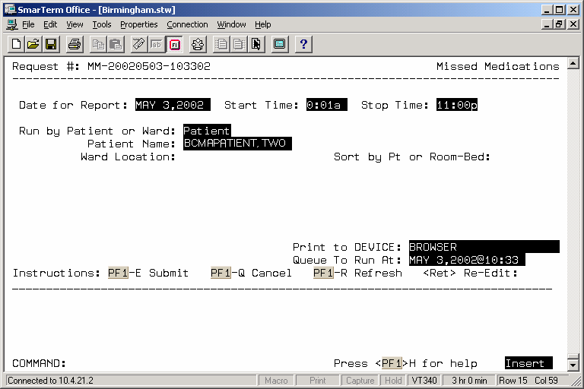

Exhibit 7: Missed Medications Report By Patient
MISSED MEDICATIONS from Jan 30, 2004@00:01 thru Jan 30, 2004@23:59
Run Date: JAN 30, 2004@08:02
Page: 1

Patient: BCMAPATIENT,ONE SSN: 000-00-9678 DOB: SEP 2,1947 (56)
Sex: MALE Ht/Wt: */* Ward: 7A GEN MED Rm 724-A
Dx: CHF Last Mvmt: DEC 2,2003@07:30:35 Type: ADMISSION

Reactions: No ADRs on file.
====================================================================================================================
Order Num Administration Date/Time Medication
--------------------------------------------------------------------------------------------------------------------
2IV Jan 30, 2004@09:00 AMPICILLIN INJ

4UD Jan 30, 2004@09:00 HALOPERIDOL TAB
(On Hold) Dec 08, 2003@12:50
10UD Jan 30, 2004@09:00 SODIUM BICARBONATE TAB

====================================================================================================================
BCMAPATIENT,ONE 000-00-9678 Ward: 7A GEN MED Room-Bed: 724-A

Exhibit 8: Missed Medications Report By Ward
MISSED MEDICATIONS from Jan 30, 2004@00:01 thru Jan 30, 2004@23:59
Run Date: JAN 30, 2004@08:14
Page: 1

Ward Location: 7A GEN MED Division: ALBANY
====================================================================================================================
Ord Num Room-Bed Patient Admin Date/Time Medication
--------------------------------------------------------------------------------------------------------------------

2IV 724-A BCMAPATIENT,ONE (9678) 1/30/04@01:00 AMPICILLIN INJ
4UD 724-A BCMAPATIENT,ONE (9678) 1/30/04@01:00 HALOPERIDOL TAB (On Hold) Dec 08, 2003@12:50
10UD 724-A BCMAPATIENT,ONE (9678) 1/30/04@01:00 SODIUM BICARBONATE TAB

2IV 724-A BCMAPATIENT,ONE (9678) 1/30/04@05:00 AMPICILLIN INJ
4UD 724-A BCMAPATIENT,ONE (9678) 1/30/04@05:00 HALOPERIDOL TAB (On Hold) Dec 08, 2003@12:50
10UD 724-A BCMAPATIENT,ONE (9678) 1/30/04@05:00 SODIUM BICARBONATE TAB

2IV 724-A BCMAPATIENT,ONE (9678) 1/30/04@09:00 AMPICILLIN INJ
4UD 724-A BCMAPATIENT,ONE (9678) 1/30/04@09:00 HALOPERIDOL TAB (On Hold) Dec 08, 2003@12:50

====================================================================================================================

Due List Report
The Due List [PSBO DL] option lets Pharmacy personnel display the Due List Report in CHUI BCMA, which displays the information available from the VDL within GUI BCMA. It provides detailed information about active and future Unit Dose and IV medication orders that are “due” for administering to a patient — during a timeframe that you specify — within a 24-hour period. Within the date/time range, the report may be printed by patient or by ward, and include the following:

- Continuous, PRN, On-Call, and One-Time Schedule Types
- Unit-Dose or IV medications
- Addendums

The Due List Report includes patient demographics data, ADR information, plus detailed information about an order, such as whether (or not) the medication is a self-med; the medication type, schedule, dose, and route; Special Instructions; administration times; Last Given date and time; Start/Stop date and time; and the individual(s) who verified the order.

 Only medications active at the time the Due List is printed will display on the report. The printed Due List and the VDL within GUI BCMA may not match if orders have been added, discontinued, or renewed after printing.

Complete the steps on the next page to enter information on the screen illustrated in Exhibit 9, Due List Report Request Screen.

Exhibit 9: Due List Report Request Screen
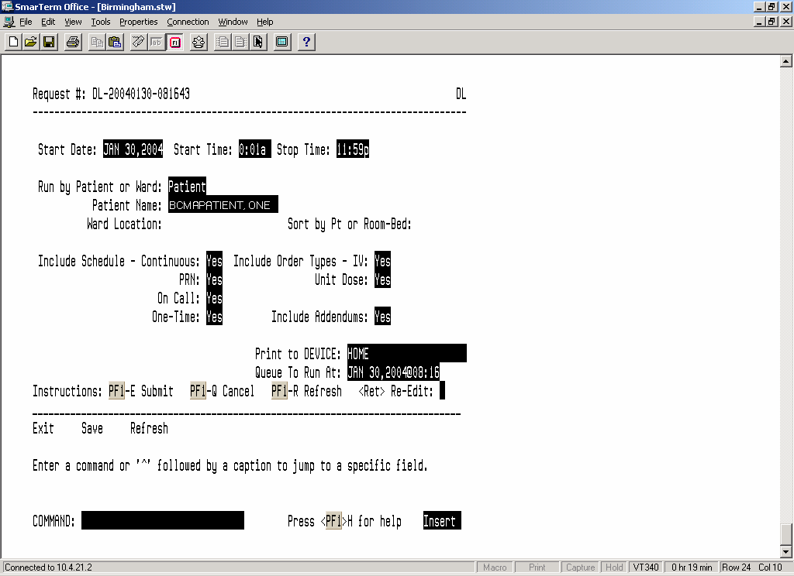
To Print a Due List Report:
- At the “Select Medication Administration Menu Pharmacy Option:” prompt, type 3, and then press <Enter> to access the Due List [PSBO DL] option.
- At the “Start Date:” prompt, type the date, and then press <Enter>.
- At the “Start Time:” prompt, type the time, and then press <Enter>.
- At the “Stop Time:” prompt, type a date, and then press <Enter>.
- At the “Run by Patient or Ward:” prompt, type P for Patient or W for Ward, and then press <Enter>.
- If you are sorting the report by patient, at the “Patient Name:” prompt, type the patient's name or SSN, and then press <Enter>.
- If you are sorting the report by ward, in the ward location, type the ward designation, and then press <Enter>. At the “Sort by Pt or Room-Bed:” prompt, type P for Patient or R for Room/Bed, and then press <Enter>.
- At the “Include Schedule:” prompts, enter Y for Yes for the desired Schedule Type(s) and N for No the others and, then press <Enter>.
- At the “Include Order Types:” prompts, enter Y for Yes or N for No at the “IV:” prompt and “Unit Dose:” prompt, and then press <Enter>. If you enter N for No at both prompts, no orders will print on the report.
- At the “Include Addendums:” prompt, enter Y for Yes or N for No, and then press <Enter>. When Y is entered, an additional section called Changes/Addendums to Orders will print at the bottom of the report. You can use this section of the report to manually record information about a medication administration.
- At the “Print to Device:” prompt, type the desired printer, and then press <Enter>.
- At the “Queue to Run At:” prompt, type the date you want to run a report, and then press <Enter>. If you press <Enter>, the system defaults to the current date and time.
- At the “<Ret> Re-Edit:” prompt, press the PF1 key followed by E (Exit) to submit the request for printing. (Other available actions at this prompt are PF1 - Q to Quit, or PF1-R to refresh the screen.)

The screen clears and the following message displays:

Submitting Your Report Request to Taskman…Submitted!
Your Task Number Is: XXXX

The reports will print in a 132-column output. Exhibit 10, Due List Report by Patient, and
Exhibit 11 Due List Report by Ward, show examples of both Due List Reports.

Exhibit 10: Due List Report by Patient
MEDICATION DUE LIST for JAN 30, 2004 0001-2400 Run Date: JAN 30, 2004@08:56
Order Type(s): IV & Unit Dose -- Continuous PRN On-Call One-Time Page: 1

Patient: BCMAPATIENT,ONE SSN: 000-00-9678 DOB: SEP 2,1947 (56)
Sex: MALE Ht/Wt: */* Ward: 7A GEN MED Rm 724-A
Dx: CHF Last Mvmt: DEC 2,2003@07:30:35 Type: ADMISSION

Reactions: No ADRs on file.
=============================================================================================================================
Self Last Start Stop Verifying
Med Sched Medication Dose Route Given Date Date Rph/Rn
@Time @Time
-----------------------------------------------------------------------------------------------------------------------------
IV-C AMPICILLIN INJ Give: Q4H IV 01/16/04@1003 12/8/03 6/21/04 A12/***
@13:30 @12:00
*AMPICILLIN (50 GM)
*DEXTROSE 5% IN N. SALINE (1000 ML) Admin Times:
0100-0500-0900-1300-1700-2100
Spec Inst: <None Entered>
-----------------------------------------------------------------------------------------------------------------------------
IV-C DEXTROSE/SALINE INJ,SOLN Give: IV 12/8/03 6/21/04 A12/***
@14:12 @12:00
*DEXTROSE 5% IN N. SALINE (1000 ML) Admin Times: 0000
Spec Inst: Bolus one bag.
-----------------------------------------------------------------------------------------------------------------------------
UD-C SODIUM BICARBONATE TAB Give: 325MG Q4H PO 01/16/04@1002 1/16/04 4/25/04 PI/***
@10:00 @12:00
*SODIUM BICARBONATE 325MG TABS(2664)Admin Times:
0100-0500-0900-1300-1700-2100
Spec Inst: <None Entered>
-----------------------------------------------------------------------------------------------------------------------------
UD-P ACETAMINOPHEN TAB Give: 650MG Q6H PRN PO 01/16/04@0945 12/8/03 6/21/04 A12/***
@12:35 @12:00
*ACETAMINOPHEN 325MG TAB (263)
Spec Inst: <None Entered>
-----------------------------------------------------------------------------------------------------------------------------
UD-P FUROSEMIDE INJ,SOLN Give: 20MG/2ML BID IVP 1/16/04 4/25/04 ***/DD
@10:28 @12:00
*FUROSEMIDE 10MG/ML 10ML INJ(651)
Spec Inst: For congestion
-----------------------------------------------------------------------------------------------------------------------------
=============================================================================================================================
BCMAPATIENT,ONE 000-00-9678 Ward: 7A GEN MED Room-Bed: 724-A

=============================================================================================================================
MEDICATION DUE LIST for JAN 30, 2004 0001-2400 Run Date: JAN 30, 2004@08:56
Order Type(s): IV & Unit Dose -- Continuous PRN On-Call One-Time Page: 2
Patient: BCMAPATIENT,ONE SSN: 000-00-9678 DOB: SEP 2,1947 (56)
Sex: MALE Ht/Wt: */* Ward: 7A GEN MED Rm 724-A
Dx: CHF Last Mvmt: DEC 2,2003@07:30:35 Type: ADMISSION

Reactions: No ADRs on file.
=============================================================================================================================

***** FUTURE ORDERS *****

Self Last Start Stop Verifying
Med Sched Medication Dose Route Given Date Date Rph/Rn
@Time @Time
-----------------------------------------------------------------------------------------------------------------------------
UD-C METHYLDOPATE INJ Give: 50MG/1ML Q6H PO 1/30/04 2/6/04 ***/DD
@18:00 @24:00
*METHYLDOPATE 250MG/5ML INJ (208) Admin Times:
0300-0900-1500-2100
Spec Inst: <None Entered>
-----------------------------------------------------------------------------------------------------------------------------
=============================================================================================================================
BCMAPATIENT,ONE 000-00-9678 Ward: 7A GEN MED Room-Bed: 724-A

Exhibit 11: Due List Report by Ward
==========================================================================================================================
MEDICATION DUE LIST for FEB 25, 2004 0001-2400 Run Date: FEB 25, 2004@11:22
Order Type(s): IV & Unit Dose -- Continuous PRN On-Call One-Time Page: 1

Patient: BCMAPATIENT,ONE SSN: 000-00-9678 DOB: SEP 2,1947 (56)
Sex: MALE Ht/Wt: */* Ward: 7A GEN MED Rm 724-A
Dx: CHF Last Mvmt: DEC 2,2003@07:30:35 Type: ADMISSION

Reactions: STRAWBERRIES
==========================================================================================================================
Self Last Start Stop Verifying
Med Sched Medication Dose Route Given Date Date Rph/Rn
@Time @Time
--------------------------------------------------------------------------------------------------------------------------
IV-C AMPICILLIN INJ Give: Q4H IV 01/16/04@1003 12/8/03 6/21/04 ***/DD
@13:30 @12:00
*AMPICILLIN (50 GM)
*DEXTROSE 5% IN N. SALINE (1000ML)
Admin Times:
0100-0500-0900-1300-1700
-2100
Spec Inst: <None Entered>
--------------------------------------------------------------------------------------------------------------------------
IV-C DEXTROSE/SALINE INJ,SOLN Give: IV 12/8/03 6/21/04 ***/DD
@14:12 @12:00
*DEXTROSE 5% IN N. SALINE (1000 ML)
Admin Times: 0000
Spec Inst: Bolus one bag.
--------------------------------------------------------------------------------------------------------------------------
UD-C SODIUM BICARBONATE TAB Give: 325MG Q4H PO 02/13/04@1100 1/16/04 4/25/04 ***/DD
@10:00 @12:00
*SODIUM BICARBONATE 325MG TABS
(2664) Admin Times:
0100-0500-0900-1300-1700
-2100
Spec Inst: <None Entered>
--------------------------------------------------------------------------------------------------------------------------
UD-P ACETAMINOPHEN TAB Give: 650MG Q6H PRN PO 02/13/04@1059 12/8/03 6/21/04 ***/DD
@12:35 @12:00
*ACETAMINOPHEN 325MG TAB (263)
Spec Inst: <None Entered>
--------------------------------------------------------------------------------------------------------------------------
UD-P FUROSEMIDE INJ,SOLN Give: 20MG/2ML BID IVP 1/16/04 4/25/04 ***/DD
@10:28 @12:00
*FUROSEMIDE 10MG/ML 10ML INJ
(651)
Spec Inst: For congestion
--------------------------------------------------------------------------------------------------------------------------
--------------------------------------------------------------------------------------------------------------------------
==========================================================================================================================
BCMAPATIENT,ONE 000-00-9678 Ward: 7A GEN MED Room-Bed: 724-A

Medication Administration History (MAH) Report
The Medication Administration History (MAH) [PSBO MH] option lets Pharmacy personnel print an MAH Report for Unit Dose and IV medication orders. This report lists a clinician’s name and initials, and the exact time that an action was taken on an order (in a conventional MAR format). Each order is listed alphabetically by the orderable item. The Date column lists three asterisks (***) to indicate that a medication was not due. This information is also noted in the Legend at the bottom of the MAH Report.

An MAH Report also includes patient demographics data, allergies and ADR information, plus detailed information about the order, such as the drug/additive/solution; the medication schedule, dose, route, and injection site; the actual administration times; the name and initials of the clinician who administered the medication; and the individuals who verified the order. It also includes information about when an order is placed “On Hold” and taken “Off Hold” by a provider, and the order Start and Stop Date/Time for the medication.

- If no parameter is defined in CPRS, the maximum date range defaults to a seven-date range. For example, a report would list the Sunday proceeding, and the Saturday following, the date that you selected for the report.

- When a student nurse is administering medications under the supervision of an instructor, and both individuals hold the appropriate security keys (i.e., PSB STUDENT and PSB INSTRUCTOR), an asterisk prints next to the student’s initials on the MAH. A legend prints at the bottom of the MAH to indicate the date/time the medication was given, along with the names of the student and the instructor.

To print an MAH Report:
- At the “Select Medication Administration Menu Pharmacy Option:” prompt, type 4, and then press <Enter> to access the Medication Administration History (MAH) [PSBO MH] option.
- See Section 3.2, “Using ScreenMan Format to Request a Report,” for instructions about requesting an MAH Report. Exhibit 12, MAH Report by Patient, shows an example of the MAH Report.

Exhibit 12: Medication Administration History Report by Patient
============================================================================================================================
Continuing/PRN/Stat/One Time Medication/Treatment Record (VAF 10-2970 B, C, D) Run Date: FEB 12, 2004@13:48
Page: 1

Patient: BCMAPATIENT,ONE SSN: 000-00-9678 DOB: SEP 2, 1947 (56)
Sex: MALE Ht/Wt: */* Ward: 7A GEN MED Rm 724-A
Dx: CHF Last Mvmt: DEC 2, 2003@07:30:35 Type: ADMISSION

ADRs: No ADRs on file.

Allergies: LATEX, STRAWBERRIES
=============================================================================================================================
Start Date Stop Date | Admin | | | | | | |
and Time and Time | Times | 02/06/2004 | 02/07/2004 | 02/08/2004 | 02/09/2004 | 02/10/2004 | 02/11/2004
-----------------------------------------------------------------------------------------------------------------------------
12/08/2003 06/21/2004 | 0100 | | | | | |
@13:30 @12:00 | 0500 | | | | | |
| 0900 | | | | | |
AMPICILLIN INJ | 1300 | | | | | |
AMPICILLIN 50 GM, DEXTROSE | 1700 | | | | | |
5% IN N. SALINE 1000 ML Give: | 2100 | | | | | |
IV Q4H INFUSE OVER 20 MIN. | | | | | | |
| | | | | | |
RPH: A12 RN: | | | | | | |
-----------------------------------------------------------------------------------------------------------------------------
12/08/2003 06/21/2004 | 0000 | | | | | |
@14:12 @12:00 | | | | | | |
| | | | | | |
DEXTROSE/SALINE INJ,SOLN | | | | | | |
DEXTROSE 5% IN N. SALINE | | | | | | |
1000 ML Give: IV 100 ml/hr | | | | | | |
Spec Inst: Bolus one bag. | | | | | | |
| | | | | | |
RPH: A12 RN: | | | | | | |
-----------------------------------------------------------------------------------------------------------------------------
12/08/2003 06/21/2004 | 0100 | | | | | |
@12:50 @12:00 | 0500 | | | | | |
| 0900 | | | | | |
HALOPERIDOL TAB | 1300 | | | | | |
HALOPERIDOL 1MG S.T. Give: | 1700 | | | | | |
2MG PO Q4H | 2100 | | | | | |
ENTERED AS ACTIVE BY | | | | | | |
PHARMACIST | | | | | | |
A12 DEC 08, 2003@12:50:05 | | | | | | |
PLACED ON HOLD BY PHARMACIST | | | | | | |
A12 DEC 08, 2003@12:50:16 | | | | | | |
RPH: A12 RN: | | HOLD | HOLD | HOLD | HOLD | HOLD | HOLD
-----------------------------------------------------------------------------------------------------------------------------
01/30/2004 02/06/2004 | 0300 | | | | | |
@18:00 @24:00 | 0900 | | | | | |
| 1500 | | | | | |
METHYLDOPATE INJ | 2100 | | | | | |
METHYLDOPATE 250MG/5ML INJ | | | | | | |
Give: 50MG/1ML PO Q6H | | | | | | |
| | | | | | |
| | | | | | |
RPH: RN: DD | | | *** | *** | *** | *** | ***
-----------------------------------------------------------------------------------------------------------------------------
01/16/2004 04/25/2004 | 0100 | | | | | |
@10:00 @12:00 | 0500 | | | | | |
| 0900 | | | | | |
SODIUM BICARBONATE TAB | 1300 | | | | | |
SODIUM BICARBONATE 325MG | 1700 | | | | | |
TABS Give: 325MG PO Q4H | 2100 | | | | | |
| | | | | | |
| | | | | | |
RPH: PI RN: | | | | | | |
-----------------------------------------------------------------------------------------------------------------------------

Initial - Name Legend

Status Codes
C - Completed
G - Given
H - Held
I - Infusing
M - Missing Dose Requested
R - Refused
RM - Removed
S - Stopped
*** - Medication Not Due

Missing Dose Request
The Missing Dose Request [PSB MISSING DOSE REQUEST] option lets you submit a Missing Dose Request to Pharmacy for filling an active medication order that is missing. This electronic request is communicated to the Pharmacy via a predefined printer and/or via an electronic MailMan message sent to a predefined mail group. Your VAMC may opt to use both mechanisms for Missing Dose Request notifications.

To submit a Missing Dose Request:
- At the “Select Medication Administration Menu Pharmacy Option:” prompt, type 5, and then press <Enter> to access the Missing Dose Request [PSB MISSING DOSE REQUEST] option. The prompts you complete are shown in Exhibit 13, Missing Dose Request Screen.
- At the “Patient Name:” prompt, type the patient’s name, and then press <Enter>.
- At the “Missing Drug:” prompt, type the medication, and then press <Enter>.

- To view a list of appropriate formats for the “Missing Drug:” prompt, enter a ? at the “Missing Drug:” prompt, and then press <Enter>. An explanation about the ways to enter a medication will display at the bottom portion of the screen.

Exhibit 13: Missing Dose Request Screen
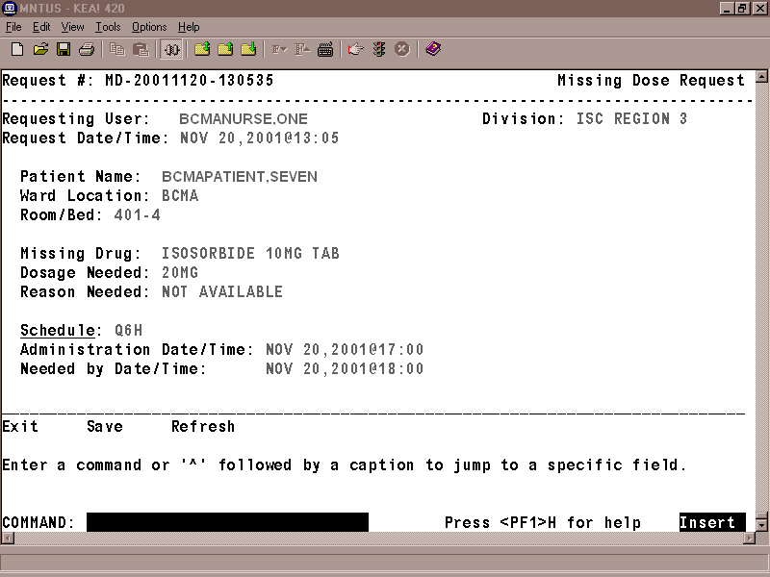
- At the “Dosage Needed:” prompt, type the dosage, and then press <Enter>.
- At the “Reason Needed:” prompt, type a reason, and then press <Enter>.

- To view a list of allowable reasons, enter a ? at the “Reason Needed:” prompt, and then press <Enter>. The list of reasons will display at the bottom portion of the screen.

- At the “Schedule:” prompt, type the schedule for the medication being requested, and then press <Enter>.
- At the “Administration Date/Time:” prompt, type a date and time (in date@time format), and then press <Enter>.
- At the “Needed by Date/Time:” prompt, type a date and time (in date@time format), and then press <Enter>.
- At the “COMMAND:” prompt, type S for Save, E for Exit, or R for Refresh, and then press <Enter>. The Missing Dose Request will print on the designated printer. The Menu Selection Screen will display with a message confirming that the request has been submitted to the Pharmacy via the appropriate mail group, as shown in Exhibit 14, Missing Dose Request Confirmation Screen.
The E-mail message that is generated displays as shown in Exhibit 15, Missing Dose E-mail Notification. The letter “M” will display in the Status column of the VDL to indicate that a Missing Dose Request was sent to the Pharmacy.

- If you try to exit the screen and the data has not been saved, the system will display the “Save changes before leaving form (Y/N)?” prompt. If you enter N for No, the data will not be saved. If you enter Y for Yes, the changes will be saved.

Exhibit 14: Missing Dose Request Confirmation Screen
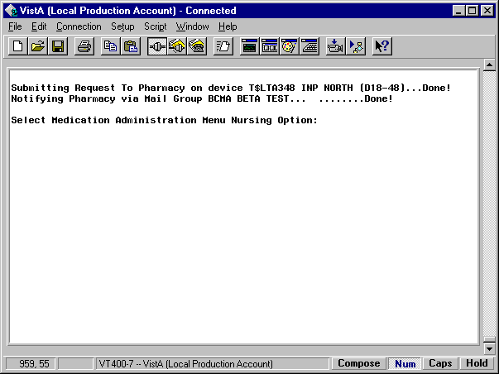

Exhibit 15: Missing Dose E-mail Notification
Subj: BCMA - Missing Dose Request [#143830] 09/24/03@09:05 17 lines
From: BCMANURSE,ONE In 'IN' basket. Page 1
---------------------------------------------------------------------

REQUEST NUMBER:.............MD-20030924-090459
DATE/TIME ENTERED:..........SEP 24, 2003@09:04
ENTERED BY:.................BCMANURSE,ONE
DIVISION:...................ALBANY, NY
SENT TO MAILGROUP:..........BCMA MISSING DOSE
PRINTED ON DEVICE:..........HOME
PATIENT:....................BCMAPATIENT,TWO
SSN (LAST 4 NUMBERS):.......1000
WARD LOCATION:..............BCMA
ROOM/BED:...................3-2
DRUG REQUESTED:.............PAPAVERINE 30MG/ML 10ML (2927)
DOSE NEEDED:................10MG
SCHEDULE:...................Q3H
REASON NEEDED:..............EMPTY PACKAGE
ADMINISTRATION DATE/TIME:...SEP 24, 2003@08:00
NEEDED BY DATE/TIME:........SEP 24, 2003@09:00

Enter message action (in IN basket): Ignore//

Missing Dose Followup
The Missing Dose Followup [PSB MISSING DOSE FOLLOWUP] option lets Pharmacy personnel electronically respond to a Missing Dose Request submitted by nursing using the VDL in GUI BCMA. Pharmacy can enter a reason that the dose was missing, the time the dose was delivered, and the name of the individual who delivered the dose.

To create a Missing Dose follow-up message:
- At the “Select Medication Administration Menu Pharmacy Option:” prompt, type 6, and then press <Enter> to access the Missing Dose Followup [PSB MISSING DOSE FOLLOWUP] option. The Missing Dose Request Screen, and the prompts you will complete, is shown in Exhibit 16.
- At the “Select Missing Dose Request # (<RET> to continue, ‘^’ to quit): (1-7):” prompt, type the number opposite the Missing Dose that you want to create a follow-up message for, and then press <Enter>. The Missing Dose Request Pharmacy Follow-up Information Screen, shown in Exhibit 17, then displays.

Exhibit 16: Missing Dose Followup Request Screen
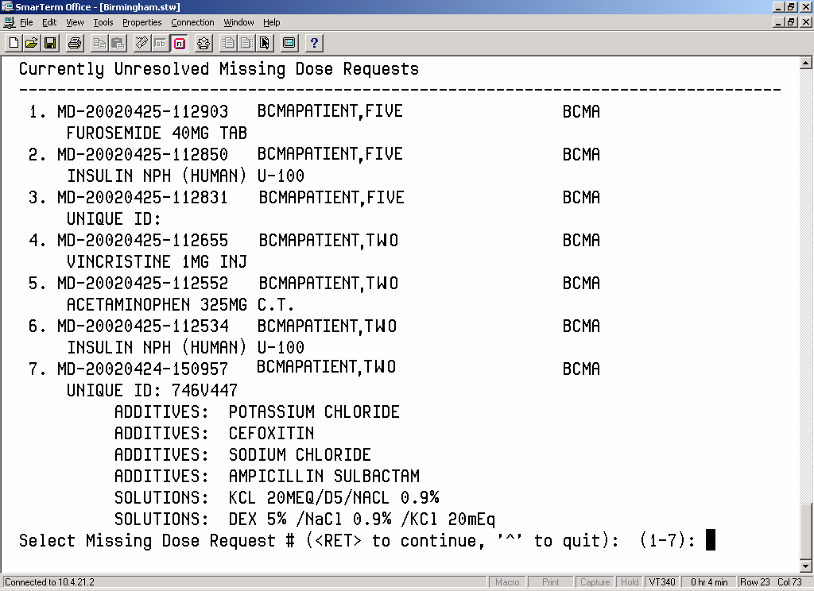

Exhibit 17: Missing Dose Request Pharmacy Follow-up Information Screen
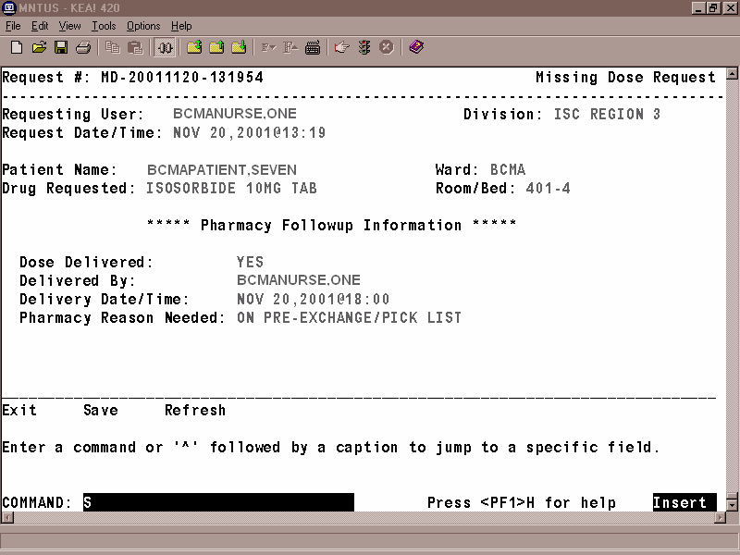

- At the “Dose Delivered:” prompt, enter Y for Yes, and then press <Enter>. If a medication is no longer active or will not be delivered, enter N for No at this prompt.

- There may be instances where a missing dose is requested for an item that is no longer active. If the medication is no longer an active order or will not be delivered, enter N for No at this prompt.

- At the “Delivery Date/Time:” prompt, enter N (for Now) or the date and time that the dose was delivered, and then press <Enter>.
- At the “Pharmacy Reason Needed:” prompt, type the number that corresponds to your selection in Exhibit 18, Pharmacy Reasons Needed Selection Table.

Exhibit 18: Pharmacy Reasons Needed Selection Table

1 | WS/FILL ON REQUEST
2 | FOUND IN DRAWER
3 | PHARMACIST ERROR
4 | EXPIRED/NO ORDER
5 | ATC ERROR
6 | NOT ENOUGH PRNS
7 | TECHNICIAN ERROR
8 | ON PRE-EXCHANGE/PICK LIST
9 | PATIENT TRANSFERRED
10 | NURSE ADMIN ERROR

- At the “COMMAND:” prompt, perform one of the following actions:
- Type S, and then press <Enter> to save the information that you entered for the Missing Dose Request selected.
- Type E, and then press <Enter> to exit the Followup Information Screen.
- Type R, and then press <Enter> to refresh the Followup Information Screen.

- If you try to exit the screen without saving the data, the system displays the “Save changes before leaving form (Y/N)?” prompt. Enter N for No, or Y for Yes, and then press <Enter>. The system confirms that the data has been saved, and returns you to the “Select Bar Code Medication Administration Manager Option:” prompt.

Missing Dose Report

The Missing Dose Report [PSBO MD] option provides information about Missing Doses that were submitted by a ward or for all wards. This report displays the total number of Missing Doses submitted for each ward location selected, the dispense drug requested, and the total number of Missing Dose Requests submitted for the dispensed drug within the selected date range.

To print a Missing Dose Report:
- At the “Select Medication Administration Menu Pharmacy Option:” prompt, type 7, and then press <Enter> to access the Missing Dose Report [PSBO MD] option. The Missing Dose Report Request Screen will display, as shown in Exhibit 19.
- At the “Start Date:” prompt, type the start date of the report, and then press <Enter>. The Missing Dose Request Pharmacy Follow-up Information Screen then displays. Note: The cursor moves to the next prompt each time that you press <Enter>.

 To display a list or a standard date and time format, enter a ? in any date or time prompt, and then press <Enter>.

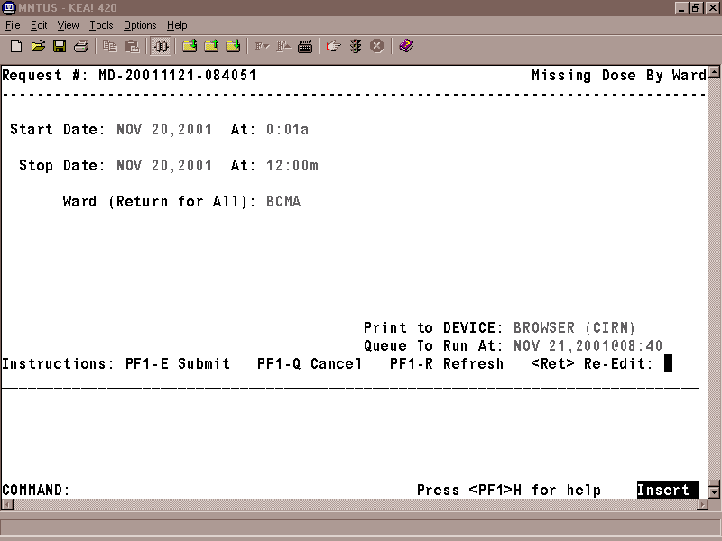
Exhibit 19: Missing Dose Report Request Screen

- At the first “At:” prompt, type the start time of the report (in HHMM format), and then press <Enter>.
- At the “Stop Date:” prompt, type the stop date, and then press <Enter>.
- At the second “At:” prompt, type the stop time (in HHMM format), and then press <Enter>.
- At the “Ward (Return for ALL):” prompt, press <Enter> to display a list of all wards, or enter the ward for which you want to run a report.
- At the “Print to DEVICE:” prompt, type a valid printer, and then press <Enter>.
- At the “Queue to Run At:” prompt, press <Enter> to accept the date displayed, or enter a date and time, and then press <Enter>. The report will print at the time and date entered.
- At the “<RET> Re-Edit:” prompt, press PF1 (or Num Lock), followed by E, to submit this report for printing. (Other available actions at this prompt are PF1-Q to Quit or PF1-R to refresh the screen.)

- Depending on how your division is configured, either the PF1 key or Num Lock will be active. For consistency, this manual refers to the PF1 convention, but users are advised that PF1 is the same as Num Lock, if that is the active function at their VAMC.

The screen clears and the following message displays:

Submitting Your Report Request to Taskman…Submitted!
Your Task Number Is: XXXX

A sample report is shown in Exhibit 20, Missing Dose Report.

Exhibit 20: Missing Dose Report
MISSING DOSE REPORT FROM SEP 24, 2003@01:00 thru SEP 26, 2003@23:00 Run Date: OCT 01, 2003@15:31
ALL WARDS Page: 1
================================================================================================================
Ward Location Medication Total
----------------------------------------------------------------------------------------------------------------

7B POST OPERATIVE ACETAMINOPHEN 650MG SUPPOS. 1
Schedule: Q4H
--------

Ward 7B POST OPERATIVE Total: 1

BCMA PAPAVERINE 30MG/ML 10ML 1
Schedule: Q3H
--------

Ward BCMA Total 1
========
Report Total: 2

Label Print
BCMA V. 3.0 includes the Label Print [PSBO BL] option for printing individual or batch Unit Dose bar code labels. It is specifically coded to the Zebra-brand printers using the Zebra Programming Language (ZPL). Model 105SE was used in the development of the labels. Routine [PSBOBL] uses site-specific printers or terminals to produce labels.

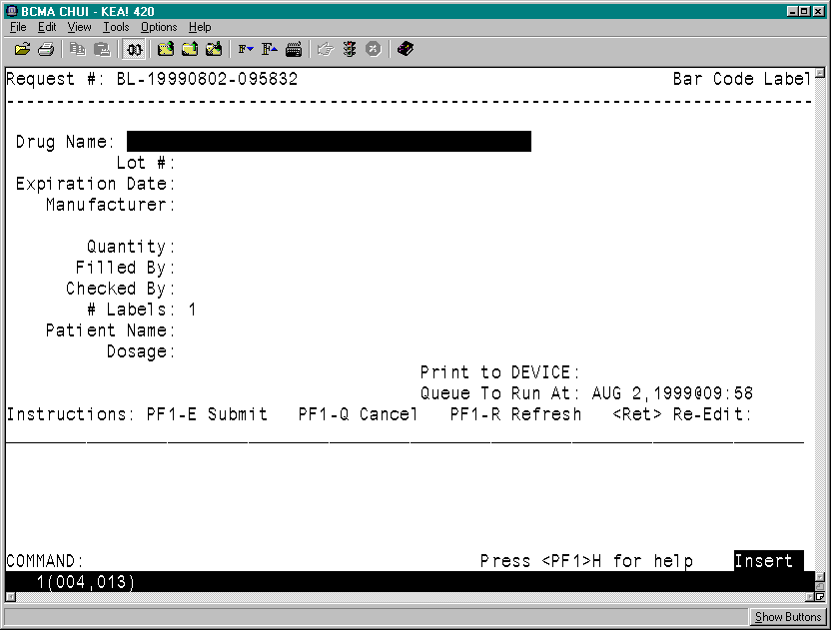
Exhibit 21: Bar Code Label Screen

To create bar code labels:
- At the “Select Medication Administration Menu Pharmacy Option:” prompt, type 8, and then press <Enter> to access the Label Print [PSBO BL] option. The Bar Code Label Screen will display, as shown in Exhibit 21.
- At the “Drug Name:” prompt, enter the drug name and then press <Enter>.
- At the “Lot #:” prompt, enter the Lot #, and then press <Enter>.
- At the “Expiration Date:” prompt, enter a date, and then press <Enter>.
- At the “Manufacturer:” prompt, enter the manufacturer's name, and then press <Enter>.
- At the “Quantity:” prompt, enter a quantity between 0.25 and 9999 (up to two decimal places), and then press <Enter>.
- At the “Filled By:” prompt, type the initials of the person who filled the order, and then press <Enter>.
- If it is unknown, leave the field blank by pressing <Enter>. This will provide space for another individual to initial the label at a later time.
- At the “Checked By:” prompt, type the initials of the person who will check the order, and then press <Enter>.

- If it is unknown, leave the field blank by pressing <Enter>. This will provide space for another individual to initial the label at a later time.
- At the “# Labels:” prompt, type the number of labels needed between 1 and 999, and then press <Enter>.
- At the “Patient Name:” prompt, type the patient’s name, and then press <Enter>.
- If preparing a Ward Stock label, leave the field blank by pressing <Enter>.
- At the “Dosage:” prompt, enter a dosage and then press <Enter>.
- The “Dosage:” prompt will accept entries from two to 30 alpha/numeric characters.
- At the “Print to Device:” prompt, type the bar code printer assigned to the ward, and then press <Enter>.
- At the “Queue to Run:” prompt, enter a date and time, and then press <Enter>.
- At the “<RET> Re-Edit:” prompt, press PF1 - E to print the label, PF1 - Q to Quit or PF1 - R to refresh the screen.

Drug File Inquiry
The Drug File Inquiry [PSB DRUG INQUIRY] option lets Pharmacy personnel check the bar-coded Internal Entry Number (IEN) Code listed on dispensed Unit Dose medications. This is particularly useful in helping resolve discrepancies when the incorrect bar code is affixed to a medication.

On a medication bar code, the IEN appears on the first line next to the Drug name. Any additional synonyms loaded into Pharmacy Data Management V. 1.0 also appear under the Synonym heading of this option.

To run a drug file inquiry:
- At the “Select Medication Administration Menu Pharmacy Option:” prompt, type 9, and then press <Enter> to access the Drug File Inquiry [PSB DRUG INQUIRY] option.
- At the “Select DRUG:” prompt, as shown in Exhibit 23, Drug File Inquiry Screen 1, type the name and dosage of the drug, and then press <Enter>.

- You can display a list or a standard format by entering a ? at the “Select DRUG:” prompt, and then pressing <Enter>. The Drug File information will display, as illustrated in Exhibit 24, Drug File Inquiry Screen 2.

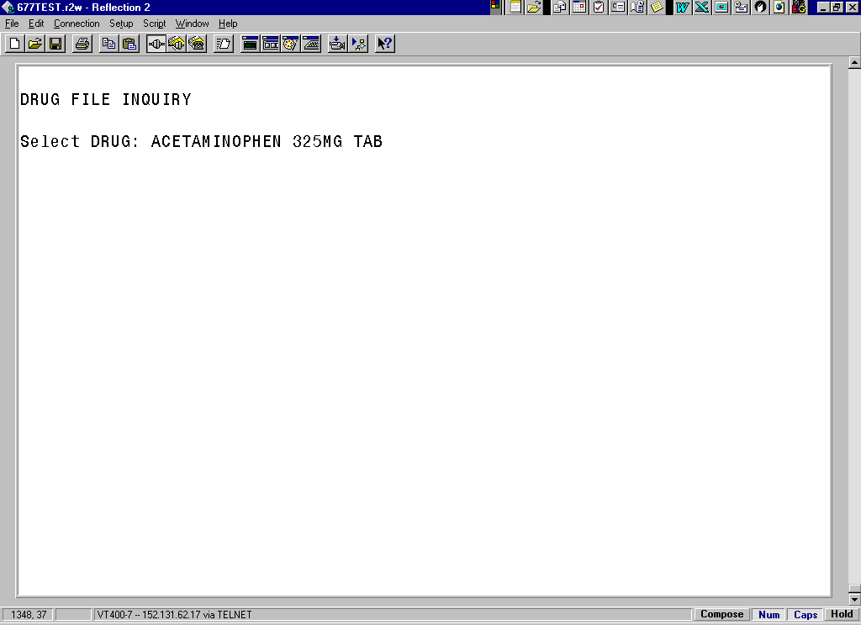
Exhibit 23: Drug File Inquiry Screen 1

Exhibit 24: Drug File Inquiry Screen 2
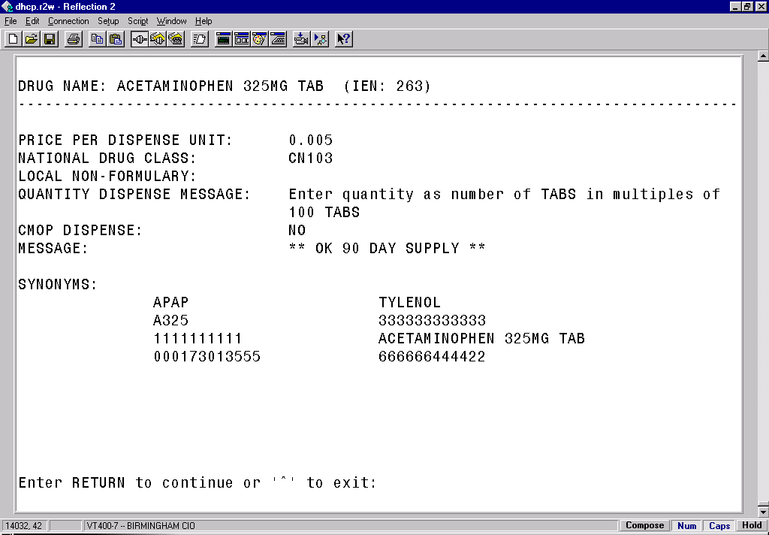

- The IEN displays on the first line, to the right of the Drug Name. The IEN is unique to this drug file entry. In most cases, it is the bar-coded number on the Unit Dose packages that are created in the Pharmacy. Manufacturers’ National Drug Code (NDC) bar codes may display at the “SYNONYMS:” prompt of this display. If the drug is Non-Formulary (N/F), the “Non-Formulary:” prompt will be set to N/F.

Bar Code Label Print
BCMA V. 3.0 includes the Barcode Label Print [PSBO BZ] option for printing individual or batch Unit Dose bar code labels. This option allows the user to have the flexibility to use any printer that has bar code printing capabilities to produce BCMA bar code labels. Routine PSBOBZ uses site-specific printers or terminals to produce labels.

Exhibit 25: Bar Code Label Print Screen
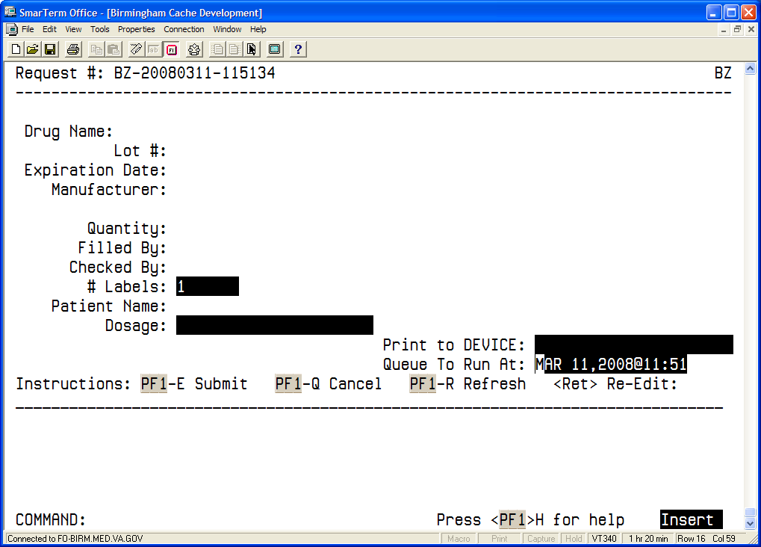

To print bar code labels:
- At the “Select Medication Administration Menu Pharmacy Option:” prompt, type 10, and then press <Enter> to access the Barcode Label Print [PSBO BZ] option. The Bar Code Label Print Screen will display, as shown in Exhibit 25.
- At the “Drug Name:” prompt, enter the drug name and then press <Enter>.
- At the “Lot #:” prompt, enter the Lot #, and then press <Enter>.
- At the “Expiration Date:” prompt, enter a date, and then press <Enter>.
- At the “Manufacturer:” prompt, enter the manufacturer's name, and then press <Enter>.
- At the “Quantity:” prompt, enter a quantity between 0.25 and 9999 (up to two decimal places), and then press <Enter>.
- At the “Filled By:” prompt, type the initials of the person who filled the order, and then press <Enter>.
- If it is unknown, leave the field blank by pressing <Enter>. This will provide space for another individual to initial the label at a later time.
- At the “Checked By:” prompt, type the initials of the person who will check the order, and then press <Enter>.
- If it is unknown, leave the field blank by pressing <Enter>. This will provide space for another individual to initial the label at a later time.
- At the “# Labels:” prompt, type the number of labels needed between 1 and 999, and then press <Enter>.
- At the “Patient Name:” prompt, type the patient’s name, and then press <Enter>.
- If preparing a Ward Stock label, leave the field blank by pressing <Enter>.
- At the “Dosage:” prompt, enter a dosage and then press <Enter>.
- The “Dosage” prompt will accept entries between 1-22 alphanumeric characters.
- At the “Print to Device:” prompt, type the name of the bar code printer assigned to the ward, and then press <Enter>.
- To view all available printers, type a question mark (?) and then press <Enter>. Type the number of the printer and then press <Enter>. The printer name populates the field
- At the “Queue to Run At:” prompt, enter a date and time, and then press <Enter>.
- At the “<RET> Re-Edit:” prompt, press PF1 - E to print the label, PF1 - Q to Quit or PF1 - R to refresh the screen. Sample labels are shown in the Exhibits below.

Exhibit 26a: Sample Unit Dose Bar Code Label
Drug: BACLOFEN 10MG TABS (Qty: 1)
Dose:25MG | Patient: BCMAPATIENT,ONE  Ward: GEN MED  Lot: 123141  Exp: 4/5/2006 Mfg: DRUGCO  Filled/Checked By: XX/XX
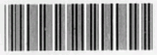
*500-2564*

Exhibit 26b: Sample Ward Stock Bar Code Label
Drug: BACLOFEN 10MG TABS (Qty: 1)
Dose:25MG | Patient:  Ward:  Lot: 123141  Exp: 4/5/2006 Mfg: DRUGCO  Filled/Checked By:_______/_______
*500-2564*

glossary
This section contains definitions for acronyms and terms used throughout this manual.

Acronyms

ADR | Adverse Drug Reaction.
BCMA | Bar Code Medication Administration.
CHUI | Character-based User Interface.
CPRS | Computerized Patient Record System.
GUI | Graphical User Interface.
IEN | Internal Entry Number.
IV | Intravenous.
MAH | Medication Administration History.
MAR | Medication Administration Record.
N/F | Non-formulary
NDC | National Drug Code.
PRN | Pro Re Nata, or “as needed.”
VDL | Virtual Due List.
VistA | Veterans Health Information Systems and Technology Architecture.

Terms

ADR | Adverse Drug Reaction. Any response to a drug which is noxious and unintended, and which occurs at doses normally used in humans for treatment, diagnosis, or therapy of a disease, or for modifying physiological functions, including toxicity caused by overdose, drug interaction, drug abuse, drug withdrawal, significant failure of expected action, food-drug interaction, or allergy.
Administration History Report | A report in CPRS that lists the date, time, and orderable item of a medication highlighted on the CPRS Meds Tab. This report is called “Medication History Report” in BCMA.
Audits | The process that tracks the activities of nurses administering medications, by recording selected types of events in the patient’s Medication Log.
BCMA | A VistA software application used in VAMCs for validating patient information and medications against active medication orders before being administered to a patient.
Clinician | VAMC personnel who administer active medication orders to patients on a ward. In a VAMC, a number of teams may be assigned to take care of one ward, with specific rooms and beds assigned to each team.
Completed | This status for an IV bag indicates that the infusion has been completed, and the bag is being taken down or replaced with a new bag. No additional actions may be taken on a bag marked as “Completed,” other than to enter comments.
Continuous Order | A medication given continuously to a patient for the life of the order, as defined by the order Start and Stop Date/Time.
CPRS | A VistA software application that allows users to enter patient orders into different software packages from a single application. All pending orders that appear in the Unit Dose and IV packages are initially entered through the CPRS package. Clinicians, managers, quality assurance staff, and researchers use this integrated record system.
Dispensed Drug | A drug whose name has the strength associated with it (e.g., Acetaminophen 325 mg). The name without the strength is called the “Orderable Item Name.”
Due List Report | A report that provides detailed information about active and future Unit Dose and IV medication orders that are “due” for administering to a patient during a time frame that you specify within a 24-hour period.
Given | When a medication is administered to a patient, it is considered to be “Given” and marked as such (with a “G”) in the Status column of the VDL.
GUI | Graphical User Interface. The type of interface chosen for BCMA.
Held | When a medication is not actually taken by a patient, it is considered to be “Held” and marked as such (with an “H”) in the Status column of the VDL. Reasons might include the patient being temporarily off the ward. You can select and mark multiple medications as Held on the VDL using the Right Click drop-down menu. In the case of IV bags, this status indicates that the dose was Held. The only actions available for this type of IV bag are to mark the bag as Infusing or Refused, or to submit a Missing Dose Request to the Pharmacy.
Hold | To display a medication order grayed out on the VDL until its Stop Date/Time or until it is Given. Some medical centers require that a nurse mark these order types as “Held,” although it is not necessary that they do so.
IEN Code | The internal entry drug number entered by Pharmacy personnel into the DRUG file (#50) to identify Unit Dose and IV medications.
IV | A medication given intravenously (within a vein) to a patient from an  IV Bag. IV types include Admixture, Chemotherapy, Hyperal, Piggyback, and Syringe.
MAH | A patient report that lists a clinician’s name and initials, and the exact time that an action was taken on an order (in a conventional MAR format). Each order is listed alphabetically by the orderable item. The Date column lists three asterisks (***) to indicate that a medication is not due. The report also lists information about when an order is placed “On Hold” and taken “Off Hold” by a provider, and the order Start and Stop Date/Time for the medication.
Medication Administration History Report | Also called “MAH,” A patient report that lists a clinician’s name and initials, and the exact time that an action was taken on an order (in a conventional MAR format). Each order is listed alphabetically by the orderable item. The Date column lists three asterisks (***) to indicate that a medication is not due. The report also lists information about when an order is placed “On Hold” and taken “Off Hold” by a provider, and the order Start and Stop Date/Time for the medication.
Medication History Report | A report in BCMA that lists the date, time, and orderable item of a medication selected on the VDL. This report is called “Administration History Report” in CPRS.
Medication Log Report | Also called “Med Log,” a report that lists every action taken on a medication order within a specified 24-hour period. You can choose to include Comments and Audits performed on the patient’s medication orders.
Missing Dose | A medication considered “Missing.” BCMA automatically marks this order type (with an “M”) in the Status column of the VDL after you submit a Missing Dose Request to the Pharmacy. If an IV bag displayed in the IV Bag Chronology display area of the VDL is not available for administration, you may mark the IV bag as a “Missing Dose” using the Missing Dose button or by right clicking the IV bag and selecting the Missing Dose command in the Right Click drop-down menu.

Missed Medications Report | A report that lists information about Continuous and One-Time Unit Dose and IV Piggyback medications that were not administered to a patient.
National Drug Code | Also called “NDC,” the number assigned by a manufacturer to each item/medication administered to a patient.
Not Given | The status that a scanned medication marked as “Given,” but not actually taken by a patient, is changed to on the VDL. The administration will display on the VDL as it appeared before it was marked as “Given.” BCMA notes the status change only in the Audit Trail section of the Medication Log (not on the VDL).
NOW Order | A medication order given ASAP to a patient, entered as a One-Time order by Providers and Pharmacists. This order type displays for a fixed length of time on the VDL, as defined by the order Start and Stop Date/Time.
On-Call Order | A specific order or action dependent upon another order or action taking place before it is carried out. For example, “Cefazolin 1gm IVPB On Call to Operating Room.” Since it may be unkn when the patient will be taken to the operating room, the administration of the On-Call Cefazolin is dependent upon that event.
One-Time Order | A medication order given one time to a patient such as a STAT or NOW a order. This order type displays for a fixed length of time on the VDL, as defined by the order Start and Stop Date/Time or until it is Given.
Orderable Item | A drug whose name does NOT have the strength associated with it (e.g., Acetaminophen 325 mg). The name with a strength is called the “Dispensed Drug Name.”
PRN Effectiveness List Report | A report that lists PRN medications administered to a patient that needs Effectiveness comments.
Provider | Another name for the “Physician” involved in the presecription of a medication (i.e., Unit Dose or IV) to a pateint.
PSB INSTRUCTOR | The name of the security “key” that must be assigned to nursing instructors, supervising nursing students, so they can access user options within BCMA V. 3.0.
PSB STUDENT | The name of the security “key” that must be assigned to nursing students, supervised by nursing instructors, so they can access user options with BCMA V. 3.0. This key requires that a nursing instructor sign on to BCMA V. 3.0.
Refused | The status for an IV bag or Unit Dose to indicate that the patient refused to take the dose.
Removed | The status for a patch (i.e., Nitroglycerin, Fentanyl, or Nicotine) to indicate that it has been removed from a patient. Once removed, the letters “RM” (for “Removed”) display in the Status column of the VDL.

Schedule | The frequency at which a medication is administered to a patient. For example, QID, QD, QAM, Q4H.
Schedule Type | Identifies the type of schedule (i.e., Continuous, PRN, On-Call, and One-Time) for the medication being administered to a patient.
Security Keys | Used to access specific options within BCMA that are otherwise “locked” without the security key. Only users designated as “Holders” may access these options.
Start Date/Time | The date and time that a medication is scheduled for administration to a patient.
STAT Order | A medication order given immediately to a patient, entered as a One-Time order by providers and pharmacists. This order type displays for a fixed length of time on the VDL, as defined by the order Start and Stop Date/Time.
Status | A code used to inform a clinician about the condition or progress of a medication order. For Unit Dose and IVP/IVPB orders, status codes include G=Given, H=Held, R=Refused, M=Missing, and RM=Removed (patch removal only). For IV orders, status codes include I=Infusing, H=Held, R=Refused, S=Stopped, C=Completed, and M=Missing.
Stop Date/Time | The date and time that a medication order will expire, and should no longer be administered to a patient.
Unit Dose | A medication given to a patient, such as tablets or capsules.
VDL | An on-line “list” used by clinicians when administering active medication orders (i.e., Unit Dose, IV Push, IV Piggyback, and large-volume IVs) to a patient. This is the Main Screen in BCMA.
Verify | When a nurse or a pharmacist confirms that a medication order is accurate and complete, according to the information supplied by the provider.
Virtual Due List | Also called “VDL,” an on-line list used by clinicians when administering active medication orders to a patient. This is the Main Screen in BCMA.

INDEX

Acronyms, 35
Bar Code Label, Sample, 34b
Barcode Label Print, 34a
BCMA, 1
On-line Help, 3
BCMA Menu, 5
Documentation Conventions, 3
Drug File Inquiry, 33
Due List Report, 15
Glossary, 35
GUI Options, 5, 15
Missing Dose E-mail Notification, 24
Missing Dose Report, 28
Pharmacy Option Menu, 5
Pharmacy Reasons Needed Selection Table, 27
Sample reports
Due List Report by Patient, 17, 18
Medication Administration History Report by Patient, 20
Medication Administration Log Report by Patient, 9
Medication Administration Log Report by Ward, 10
Missed Medications by Ward Report, 14
Missed Medications Report by Patient, 13
Missed Medications Report Screen, 12
Missing Dose Report, 29, 30
Sample screens
Bar Code Label Print Screen, 34a
Drug File Inquiry Screen 1, 33
Drug File Inquiry Screen 2, 34
Due List Report Request Screen, 15, 25
Missing Dose Follow Up Request Screen, 25
Missing Dose Request Confirmation Screen, 23
Missing Dose Request Pharmacy Follow-up Information Screen, 26
Missing Dose Request Screen, 21
BCMA Pharmacy Option Menu Screen, 5
Medication Administration Log Report Screen, 8
Using ScreenMan Format to Request a Report, 6
Sample Unit Dose Bar Code Label, 34b
Sample Ward Stock Bar Code Label, 34b
Terms, 36
Using the Pharmacy Menu Options
Request a Report, 6
Medication Administration Log Report, 8
Missed Medications Report, 11
Due List, 15
Medication Administration History (MAH), 19
Missing Dose Request, 21, 28
Missing Dose Follow-up, 25
Drug File Inquiry, 33

